**Q1**: There are totally 149 nodes and 41 zones in the West Jordan network.

**Q2**: Speed limit of the segment on the west of node 5114 is 39 mph, and 32 mph for the rest part. Also, there two lanes presented along 9000 South in the Base Condition model.

**Q3**: Link capacity is the maximum number of vehicles expected to pass through a certain site of a link in a given time interval, while lane capacity should be the maximum number of vehicles expected to pass through a certain site of a lane. Normally, link capacity can be calculated as lane capacity multiplied by corresponding number of lanes on the link.

**Q4**: The link capacity of Redwood Road decrease slowly along with the north direction (from 930 vehicle/h to 892 vehicle/h then 854 vehicle/h).

**Q5**: 12638 vehicles have been simulated according to the output_summary.csv file.

**Q6**: The average travel time, average trip time index, average speed, and network clearance time (in minutes) for the last iteration is 6.43 min, 1.16, 28.18 mph, 1440 min respectively.

Figure 1 Simulation statistics in different iteration

As can be seen from the Figure 1, average travel times decrease while speeds increase as the iteration number increases. At the beginning of simulation, all vehicles chose the shortest path (travel time or distance) as travelling route and that may lead to serious congestion in part routes (high travel time and low travel speed). In following iterations (days), vehicles adjust travelling route based on traffic condition in previous iteration (day) and finally reach equilibrium that each road on the network is utilized suitably.

**Q7**: In this simulation with work zone, the average travel time, average trip time index, average speed, and network clearance time (in minutes) for the last iteration is 11.41 min, 2.05, 15.98 mph, and 1440 min. Compared with the results of the “no work zone” model, average travel time and average trip time index increase significantly while average speed decreases.

**Q8**:

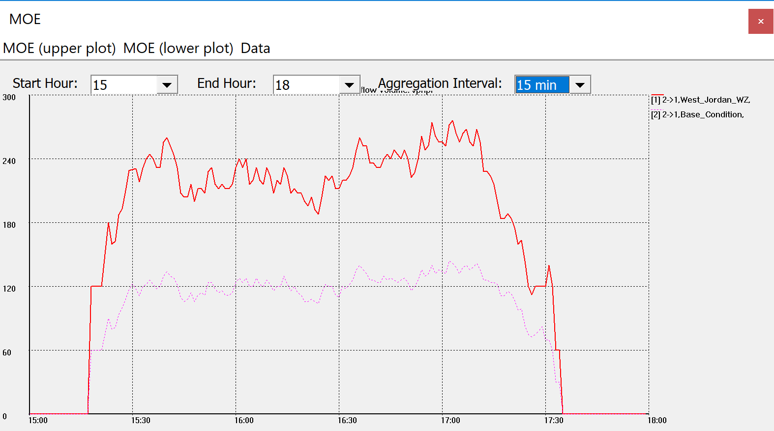

Figure 2 Lane flow comparison between base condition and work zone condition in link 2->1

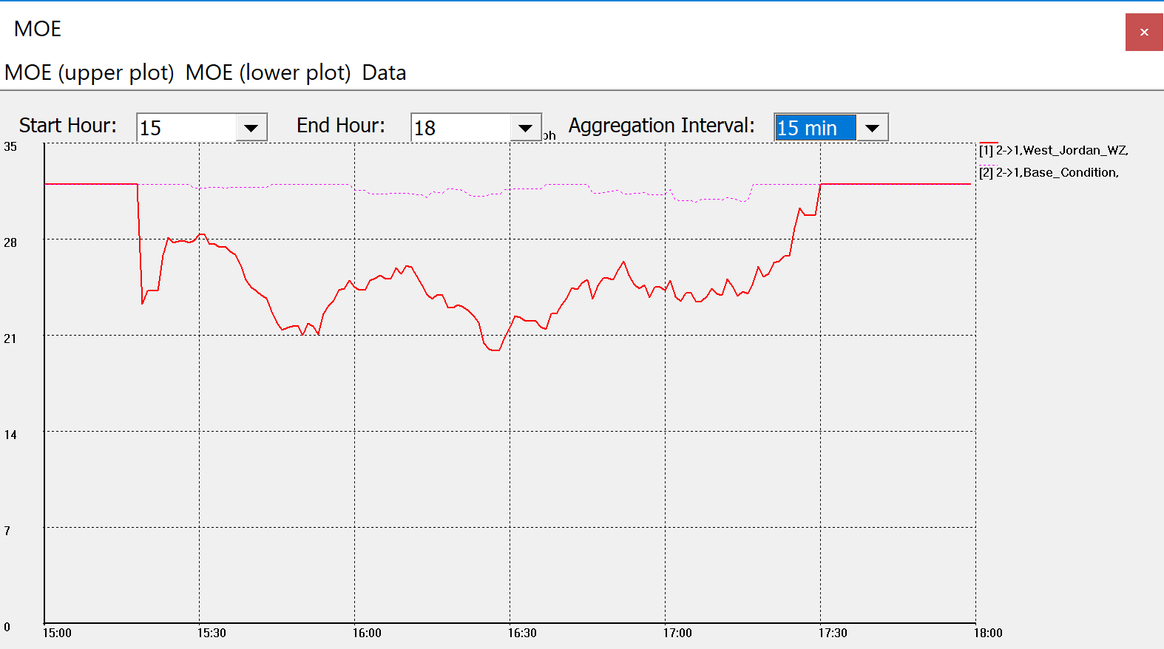

Figure 3 Speed comparison between base condition and work zone condition in link 2->1

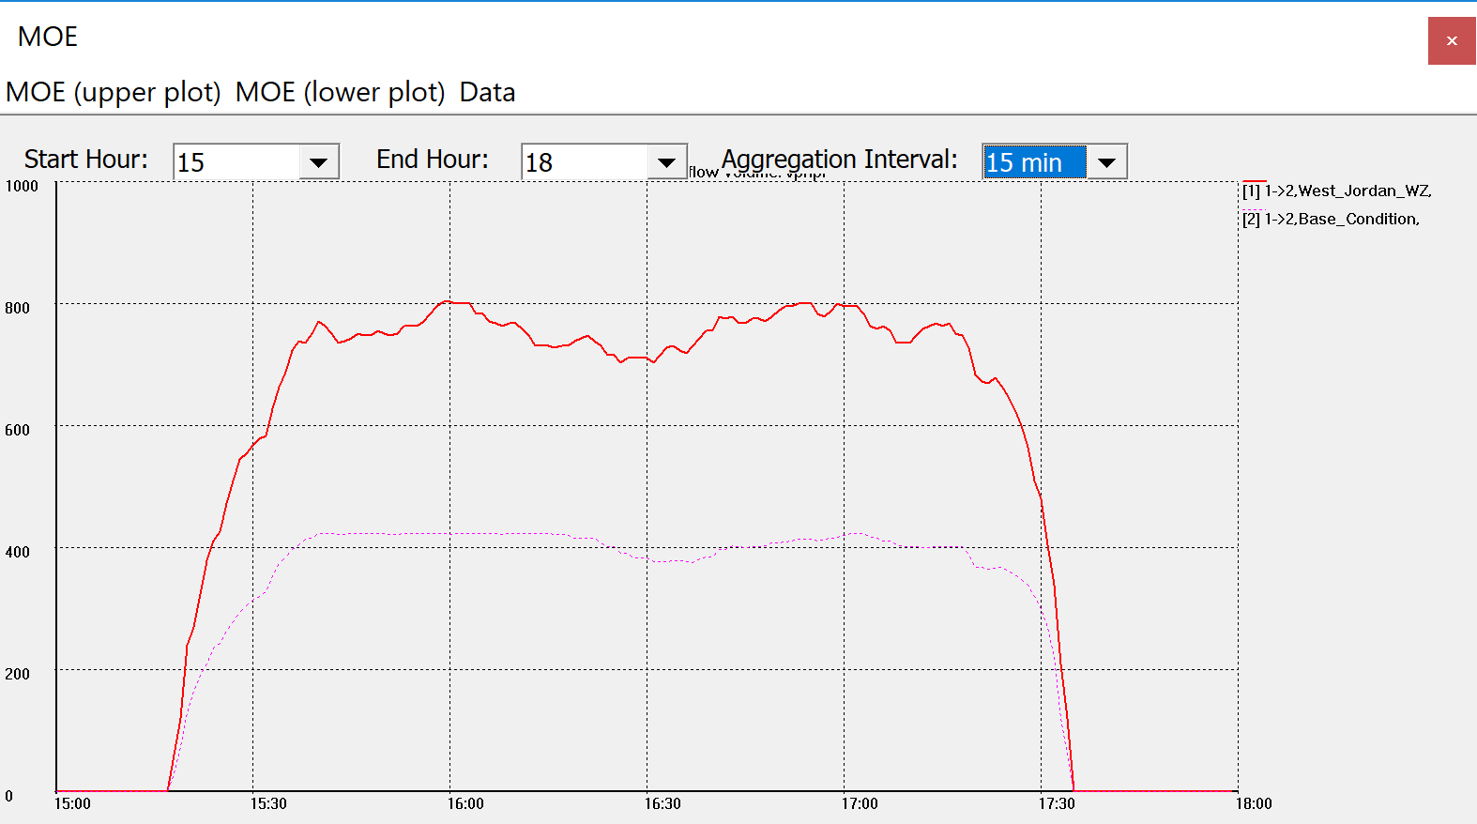

Figure 4 Lane flow comparison between base condition and work zone condition in link 1->2

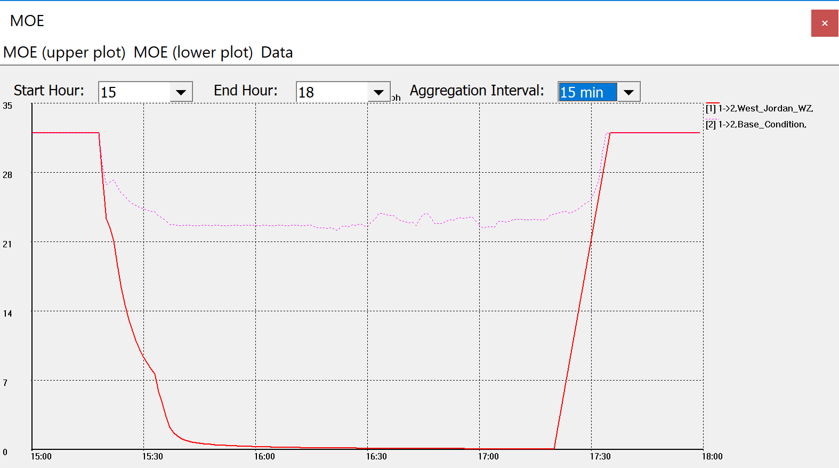

Figure 5 Speed comparison between base condition and work zone condition in link 1->2

**Q9**: The lane volume in network with work zone is significantly larger than that in base network, while speed is lower that base condition. The larger lane volume and lower speed mean that work zone will bring significant influence on the network. Also, link 1->2 experiences more congestion compared with link 2->1.